Date: 11.08.2026
Domain Domain: Real-Time Pedestrian Detection System for Advanced Driver Assistance Systems (ADAS)
Project Type:
Real-Time Computer Vision and Deep Learning-Based Detection System primary Focus: Real-time pedestrian detection, road safety, object recognition, collision risk awareness, and driver assistance.
2. Objectives
The main objective of this project is to develop a real-time pedestrian detection system for Advanced Driver Assistance Systems (ADAS) that can accurately identify pedestrians from live video or camera input and improve road safety by providing timely awareness of potential pedestrian-related hazards.
Specific Objectives
- Develop a real-time vision-based pedestrian detection system for ADAS applications.
- Capture and process live video or camera input to continuously monitor the road environment.
- Detect and identify pedestrians using computer vision and deep learning techniques.
- Generate bounding boxes around detected pedestrians along with confidence scores.
- Achieve efficient real-time detection with minimum processing delay.
- Improve pedestrian safety by identifying pedestrians who may be present in the vehicle's path.
- Enable the system to support collision risk awareness and driver assistance.
- Evaluate the performance of the system using metrics such as:
  - Detection accuracy
  - Precision
  - Recall
  - Confidence score
  - Processing speed / Frames Per Second (FPS)
  - Detection performance under different environmental conditions

3. Current Implementation Boundary
The development of the project is completed up to the following stages:
Project
↓
Camera / Video Input
↓
Video Frame Acquisition
↓
Frame Preprocessing
↓
Pedestrian Detection Model
↓
Real-Time Pedestrian Identification and Bounding Box Generation
- The tracking, distance estimation, alert generation, performance optimization, and real-time evaluation portion is the next development stage.
- Dataset
4. Dataset
- For this project, the Penn-Fudan Pedestrian Dataset is a relevant reference dataset because the project focuses on detecting pedestrians in images and video frames.
- The dataset contains images of pedestrians captured in different real-world environments. It provides pedestrian annotations that can be used for training and evaluating pedestrian detection models.
- The dataset is useful for:
- Pedestrian detection
- Object detection model training
- Bounding-box generation
- Computer vision research
- Model performance evaluation
- Real-time pedestrian detection development
- Dataset Contents
- The dataset primarily consists of:
- Pedestrian images
- Pedestrian bounding-box annotations
- Different pedestrian poses and appearances
- Different background environments
- Images containing multiple pedestrians
- Usage in the Project
- The dataset can be used to train and evaluate the pedestrian detection model. After training, the model can receive frames from a live camera or video stream and identify pedestrians by generating bounding boxes around detected persons.
- The overall dataset-to-system flow is:
- Dataset
↓
Image Preprocessing
↓
Pedestrian Detection Model
↓
Model Training
↓
Model Evaluation
↓
Real-Time Camera / Video Input
↓
Pedestrian Detection
↓
Bounding Box + Detection Output
DATA SET WEBSITE :- https://www.kaggle.com/datasets/kalvinquackenbush/caltechpedestriandataset
Architecture of the project :-
### 5. Architecture of the Project

The architecture of the proposed Real-Time Pedestrian Detection System is:

**Camera / Video Input**
↓
**Video Frame Acquisition**
↓
**Frame Preprocessing**
↓
**Pedestrian Detection Model**
↓
**Object Detection & Classification**
↓
**Bounding Box Generation**
↓
**Pedestrian Count / Detection Output**
↓
**Real-Time Display**

### Architecture Flow

Camera / Video Stream
│
▼
Frame Extraction
│
▼
Image Preprocessing
│
▼
Pedestrian Detection Model
│
▼
Person Detection
│
▼
Bounding Box Generation
│
▼
Confidence Filtering
│
▼
Real-Time Pedestrian Detection
│
▼
Display / Output

The camera or video stream provides continuous frames to the system. Each frame is preprocessed and passed to the pedestrian detection model. The model identifies pedestrians and generates bounding boxes around the detected persons. Confidence filtering is then applied to remove low-confidence detections. Finally, the detected pedestrians and their bounding boxes are displayed in real time.
Work flow of our project :-
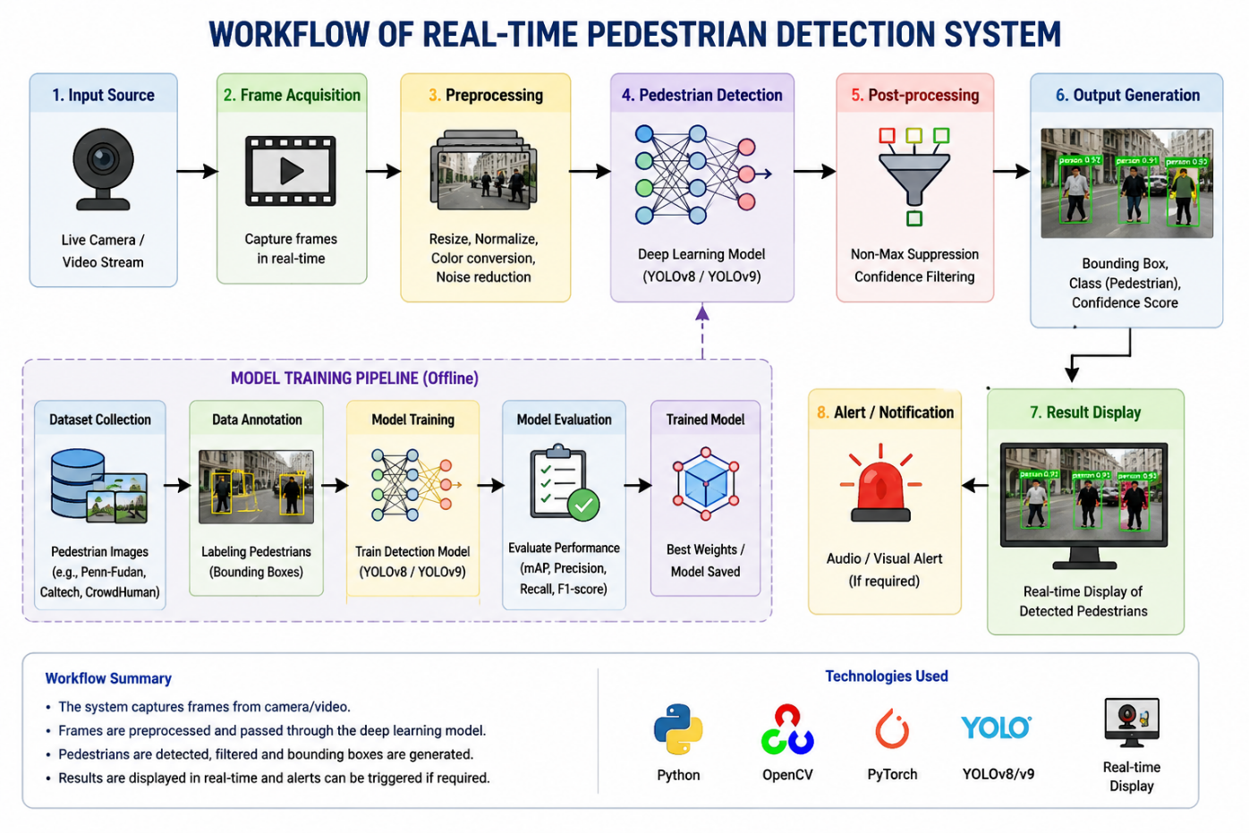

METHODOLOGY OVERVIEW :-
6. Methodology Overview
The complete methodology of the Real-Time Pedestrian Detection System can be summarized as:
Pedestrian Dataset
↓
Data Collection and Annotation
↓
Image Preprocessing
↓
Pedestrian Detection Model Training
↓
Model Evaluation
↓
Live Camera / Video Input
↓
Real-Time Frame Acquisition
↓
Frame Preprocessing
↓
Pedestrian Detection
↓
Confidence Filtering & Bounding Box Generation
↓
Pedestrian Counting / Tracking
↓
Real-Time Result Display
↓
Alert / Notification (if required)
The system first uses a pedestrian dataset to train and evaluate the detection model. After obtaining a trained model, live video frames are captured from a camera or video source. Each frame is preprocessed and passed to the trained detection model. The model identifies pedestrians and generates bounding boxes with confidence scores. The detected results are then processed and displayed in real time, with an optional alert mechanism for detected pedestrians.
Current Progress: The project foundation, dataset preparation, preprocessing pipeline, pedestrian detection model setup, and basic real-time detection pipeline are the initial development stages. Model optimization, pedestrian tracking/counting, alert generation, and quantitative real-time performance evaluation are the subsequent development stages.

Team Members

2420030349 A Gnana Sai Srinivas
2420030562 M Pranay Sai Varma
2420030528 S Roshan Sai Krishna

